**Project Overview**

This network simulation was created in Cisco Packet Tracer to demonstrate a fully functional small-scale enterprise network. The topology includes multiple routers, switches, end devices (PCs), and servers connected via copper straight-through and serial cables. The network supports routing protocols such as EIGRP, OSPF, and RIP, and implements Network Address Translation (NAT) and Access Control Lists (ACLs) for optimized traffic control and security. All physical interconnections were thoroughly tested to ensure Layer 1 and Layer 2 connectivity, aligning with the intended enterprise network design.

**Vlsm Tree table(Networks)**

|  |  |  |  |
| --- | --- | --- | --- |
| **Network** | **CIDR** | **Usable IP Range** | **Subnet Mask (Dotted Decimal)** |
| K | /17 | 65.142.0.1 – 65.142.127.254 | 255.255.128.0 |
| C | /18 | 65.142.128.1 – 65.142.191.254 | 255.255.192.0 |
| A | /18 | 65.142.192.1 – 65.142.255.254 | 255.255.192.0 |
| G | /19 | 65.143.0.1 – 65.143.31.254 | 255.255.224.0 |
| I | /19 | 65.143.32.1 – 65.143.63.254 | 255.255.224.0 |
| D | /19 | 65.143.64.1 – 65.143.95.254 | 255.255.224.0 |
| F | /19 | 65.143.96.1 – 65.143.127.254 | 255.255.224.0 |
| B | /22 | 65.143.176.1 – 65.143.179.254 | 255.255.252.0 |
| H | /19 | 65.143.128.1 – 65.143.159.254 | 255.255.224.0 |
| E | /20 | 65.143.160.1 – 65.143.175.254 | 255.255.240.0 |
| J | /24 | 65.143.180.1 – 65.143.180.254 | 255.255.255.0 |

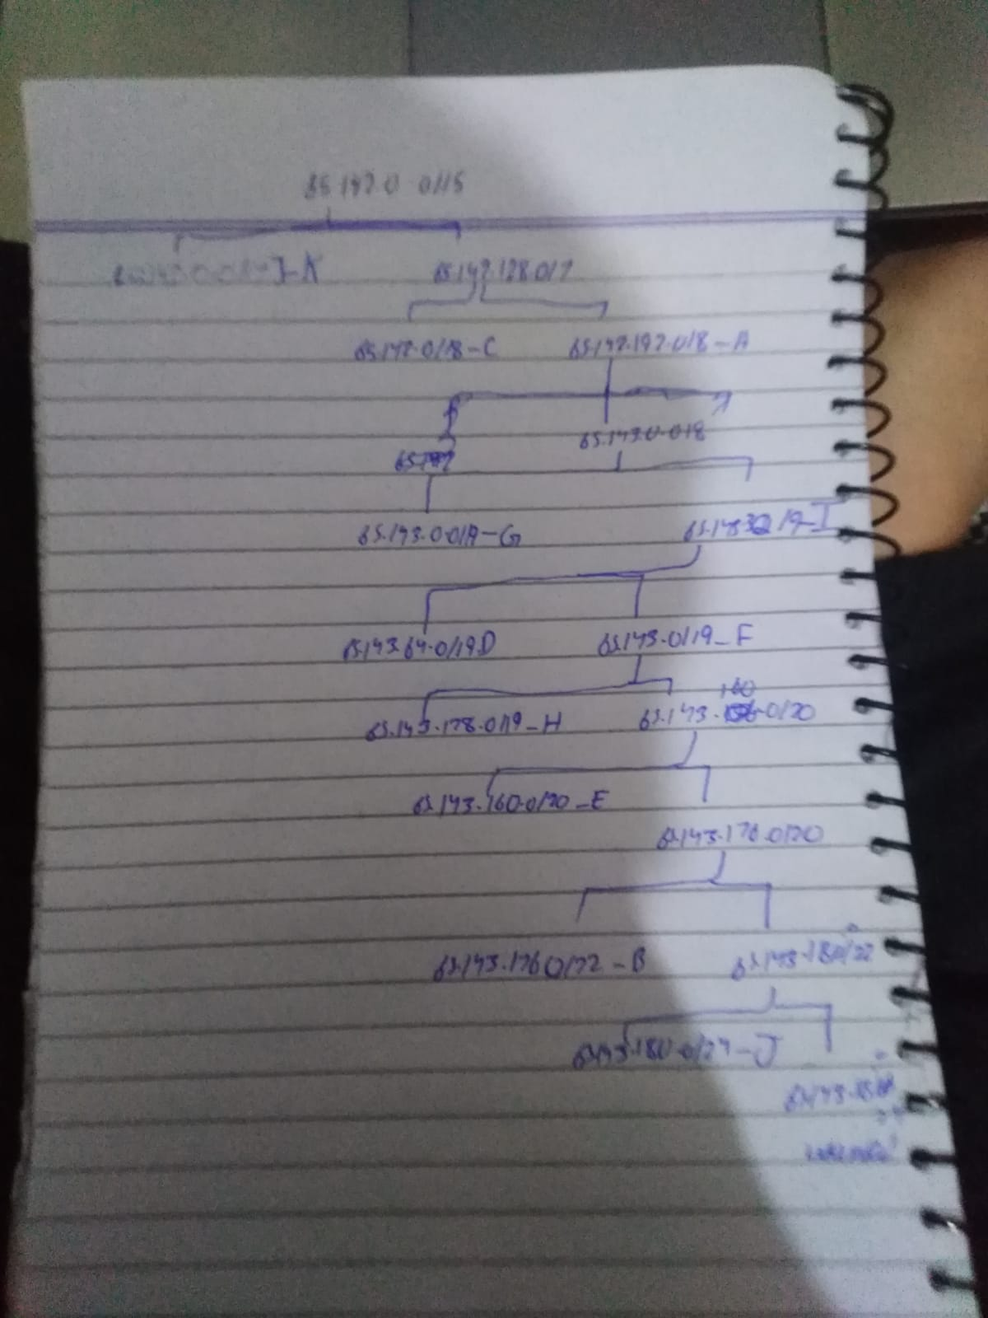

**Vlsm tree table ( routers to routers)**

|  |  |  |  |  |  |
| --- | --- | --- | --- | --- | --- |
| **Link No.** | **CIDR** | **Block Size** | **Subnet Address** | **Broadcast Address** | **Usable Range** |
| R1 | /30 | 4 | 65.143.181.0 | 65.143.181.3 | 65.143.181.1 - 65.143.181.2 |
| R2 | /30 | 4 | 65.143.181.4 | 65.143.181.7 | 65.143.181.5 - 65.143.181.6 |
| R3 | /30 | 4 | 65.143.181.8 | 65.143.181.11 | 65.143.181.9 - 65.143.181.10 |
| R4 | /30 | 4 | 65.143.181.12 | 65.143.181.15 | 65.143.181.13 - 65.143.181.14 |
| R5 | /30 | 4 | 65.143.181.16 | 65.143.181.19 | 65.143.181.17 - 65.143.181.18 |
| R6 | /30 | 4 | 65.143.181.20 | 65.143.181.23 | 65.143.181.21 - 65.143.181.22 |
| R7 | /30 | 4 | 65.143.181.24 | 65.143.181.27 | 65.143.181.25 - 65.143.181.26 |
| R8 | /30 | 4 | 65.143.181.28 | 65.143.181.31 | 65.143.181.29 - 65.143.181.30 |
| R9 | /30 | 4 | 65.143.181.32 | 65.143.181.35 | 65.143.181.33 - 65.143.181.34 |
| R10 | /30 | 4 | 65.143.181.36 | 65.143.181.39 | 65.143.181.37 - 65.143.181.38 |
| R11 | /30 | 4 | 65.143.181.40 | 65.143.181.43 | 65.143.181.41 - 65.143.181.42 |
| R12 | /30 | 4 | 65.143.181.44 | 65.143.181.47 | 65.143.181.45 - 65.143.181.46 |
| R13 | /30 | 4 | 65.143.181.48 | 65.143.181.51 | 65.143.181.49 - 65.143.181.50 |
| R14 | /30 | 4 | 65.143.181.52 | 65.143.181.55 | 65.143.181.53 - 65.143.181.54 |
| R15 | /30 | 4 | 65.143.181.56 | 65.143.181.59 | 65.143.181.57 - 65.143.181.58 |
| R16 | /30 | 4 | 65.143.181.60 | 65.143.181.63 | 65.143.181.61 - 65.143.181.62 |
| R17 | /30 | 4 | 65.143.181.64 | 65.143.181.67 | 65.143.181.65 - 65.143.181.66 |
| R18 | /30 | 4 | 65.143.181.68 | 65.143.181.71 | 65.143.181.69 - 65.143.181.70 |
| R19 | /30 | 4 | 65.143.181.72 | 65.143.181.75 | 65.143.181.73 - 65.143.181.74 |
| R20 | /30 | 4 | 65.143.181.76 | 65.143.181.79 | 65.143.181.77 - 65.143.181.78 |
| R21 | /30 | 4 | 65.143.181.80 | 65.143.181.83 | 65.143.181.81 - 65.143.181.82 |
| R22 | /30 | 4 | 65.143.181.84 | 65.143.181.87 | 65.143.181.85 - 65.143.181.86 |
| R23 | /30 | 4 | 65.143.181.88 | 65.143.181.91 | 65.143.181.89 - 65.143.181.90 |

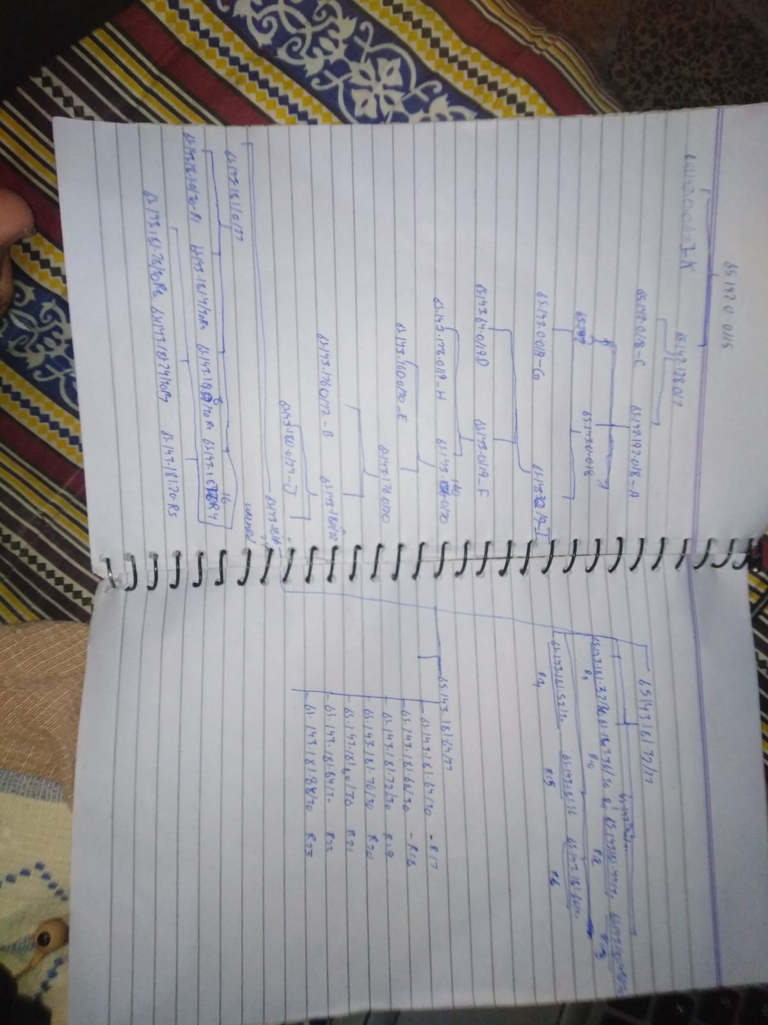

**Network Topology**

* **Devices Used:**
  + 19 Routers (2811)
  + 7 Switches (Generic)
  + 8 PCs (Generic)
  + 3 Server (Email,DHCP,Web Server)
  + 23 Serial Wires
  + 3 Acess points
  + 6 Laptops
  + 4Smart Phones
  + 2 Table pc
  + 2 Copper wire
  + 24 Copper straight wire
* **Network Segments:**
* Internal LAN: 192.168.1.0/24
* Public IP: 65.142.177.13
* DHCP server ip: 65.142.127.254
* Email server ip: 65.142.191.254
* Web server ip : by usinh dhcp

**Ip configuration:**

| **Device** | **Label** | **IP Address** | **Interface** |
| --- | --- | --- | --- |
| Router | R0 | 65.142.192.1 | Fa0/0 |
| Router | R0 | 65.143.181.1 | Se0/3/0 |
| Router | R1 | 65.143.176.1 | Fa0/0 |
| Router | R1 | 65.143.181.5 | Se0/3/1 |
| Router | R1 | 65.143.181.2 | Se0/3/0 |
| Router | R1 | 65.143.181.9 | Se0/1/0 |
| Router | R2 | 65.143.181.6 | Se0/1/0 |
| Router | R2 | 65.143.181.13 | Se0/1/1 |
| Router | R2 | 65.143.181.17 | Se0/3/0 |
| Router | R3 | 65.143.181.10 | Se0/1/1 |
| Router | R3 | 65.143.181.14 | Se0/1/0 |
| Router | R4 | 65.143.181.18 | Se0/3/0 |
| Router | R4 | 65.143.181.21 | Se0/3/1 |
| Router | R5 | 65.143.181.22 | Se0/3/1 |
| Router | R5 | 65.143.181.25 | Se0/3/0 |
| Router | R6 | 65.143.181.26 | Se0/1/0 |
| Router | R6 | 65.143.181.22 | Se0/3/0 |
| Router | R6 | 65.143.181.25 | Se0/3/1 |
| Router | bs | 65.143.160.1 | Fa0/0 |
| Router | Bs | 65.143.181.34 | Se0/1/0 |
| Router | Bs | 65.143.181.45 | Se0/1/1 |
| Router | Bs | 65.143.181.37 | Se0/3/0 |
| Router | R8 | 65.143.64.1 | Fa0/0 |
| Router | R8 | 65.143.181.30 | Se0/3/0 |
| Router | R8 | 65.143.181.41 | Se0/3/1 |
| Router | R9 | 65.143.96.1 | Fa0/0 |
| Router | R9 | 65.143.181.38 | Se0/1/0 |
| Router | R9 | 65.143.181.42 | Se0/1/1 |
| Router | R9 | 65.143.181.50 | Se0/3/0 |
| Router | R10 | 65.143.181.49 | Se0/1/0 |
| Router | R10 | 65.143.181.46 | Se0/1/1 |
| Router | R10 | 65.143.181.53 | Se0/3/0 |
| Router | R12 | 65.143.181.61 | Se0/1/0 |
| Router | R12 | 65.143.181.66 | Se0/1/1 |
| Router | R12 | 65.143.181.54 | Se0/3/0 |
| Router | R12 | 65.143.181.57 | Se0/3/1 |
| Router | R13 | 65.143.0.1 | Fa0/0 |
| Router | R13 | 65.143.181.58 | Se0/3/0 |
| Router | R14 | 65.143.128.1 | Fa0/0 |
| Router | R14 | 65.143.32.1 | Fa0/1 |
| Router | R14 | 65.143.181.62 | Se0/3/0 |
| Router | R18 | 65.143.181.65 | Se0/1/0 |
| Router | R18 | 65.143.181.69 | Se0/1/1 |
| Router | R18 | 65.143.180.1 | Fa0/0 |
| Router | R17 | 65.143.181.65 | Se0/1/0 |
| Router | R17 | 65.143.181.69 | Se0/1/1 |
| Router | R16 | 65.143.181.90 | Se0/1/0 |
| Router | R16 | 65.143.181.82 | Se0/3/0 |
| Router | R16 | 65.143.181.85 | Se0/3/1 |
| Router | R14 | 65.142.0.1 | Fa0/0 |
| Router | R14 | 65.143.181.81 | Se0/3/0 |
| Router | R14 | 65.143.181.78 | Se0/3/1 |
| Router | R16 | 65.143.181.74 | Se0/1/0 |
| Router | R16 | 65.143.181.77 | Se0/1/1 |
| Router | R16 | 65.143.181.89 | Se0/3/0 |

**3. Routing Protocol Configuration**

The following routing protocols were correctly implemented:

* RIP for inter-LAN routing in legacy zones.
* OSPF for dynamic internal routing (Area 1,2).
* EIGRP for modern edge routing with rapid convergence.

Redistribution between routing protocols was performed where necessary. Static and dynamic routing coexist to facilitate specific reachability.

Routing confirmed through successful end-to-end pings and traceroutes.

**4. DHCP Server Configuration**

A DHCP server was configured on Router R1 to dynamically assign IP addresses to clients in LAN1. IP pools were defined with correct subnet masks, DNS servers, and default gateway settings. PCs received addresses via DHCP and were able to communicate on the network.

Dynamic IP assignment verified on PC’s

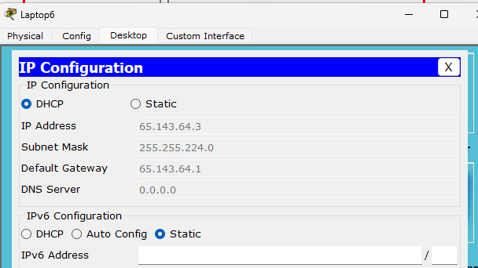

**NAT Configuration**

Router R8 and 20 was configured for PAT (Port Address Translation):

Inside and outside interfaces were marked. Successful translation was verified using:

* show ip nat translations

Internal PCs successfully accessed external networks using a single public IP.

Router 8 with network e

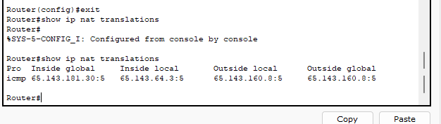

Router 20 to j

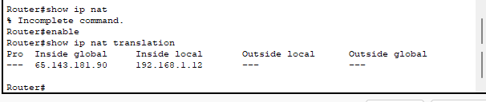

**6. ACL Implementation**

Access Control Lists were used to restrict access:

* network 65.143.127.255 blocked
* Other PCs allowed

**Email Configuration**

SMTP server (e.g., 65.142.191.254) was configured to enable internal mail communication. Al the pc’s set with valid email clients and user credentials. Successful email exchange verified.

Host-to-host mail exchange confirmed via Packet Tracer simulation.

Domain =gmail.com